Minutes of the 3rd meeting of RILEM TC-CCC WG4
August 27, 2020, Online
Time | 9:00-12:30, Friday, 27 August, 2020 (UTC+2)  [15:00-18:30, Beijing Time]
Venue | Microsoft Teams Online Meeting Room
Main Subjects | - Discussion on the test results of the 1st test series of 7 labs  - Possible modifications of the test program  - Discussion on detailed plan of the 2nd test series
Participants | Altogether 21 participants from 7 countries attended the meeting:  --- 7 participants from China Building Materials Academy (CBMA):  Ling WANG, Juan LI, Zhendi WANG, Yin CAO, Cheng ZHANG, Xinyu SHI, Bin LI  --- 3 participants from Ghent University:  Philip VAN DEN HEEDE, Nele DE BELIE, Zhiyuan LIU  --- 11 participants from other universities and organizations:  Muhammed BASHEER, Visalakshi TALAKOKULA, Tushar BANSAL, Chuansheng XIONG, Quoc Tri PHUNG, Ivan IGNJATOVIC, Kolawole OLONADE, Siham KAMALI-BERNARD, Hao BAO, Jianwei WANG, Yu HUANG
Moderator | Juan LI

At the beginning of the meeting, Prof. Ling WANG, the co-chairlady of RILEM TC 281 WG4, warmly welcomed all the participants and made an opening speech on behalf of the chairlady of WG4 Prof. Yan YAO. After all the participants’ self-introduction, Prof. Juan LI from CBMA introduced the meeting agenda, the minutes of the last meeting and the brief review on WG4 ongoing work. After detailed discussion on the recent tasks and the next steps of WG4 of RILEM TC-281 CCC, the following agreements were reached.
1. The Results of 1st Test Series of 7 Labs
Due to the COVID-19, several labs’ progresses were behind the plan. However, three laboratories still finished the test on time. Mr. Zhiyuan LIU from Magnel Laboratory of Ghent University, Mr. Cheng ZHANG, Mr. Xinyu SHI from CBMA and Prof. Visalakshi TALAKOKULA from Bennett University introduced their work progresses repectively. The stress effect on carbonation investigated by CBMA and Bennett University were completely opposite, while no evidently effect of applied stress on carbonation depth was observed in UGent. Since the outcomes of three laboratories were quite different, a detailed report of the 1st test series in three laboratories was planned to be proposed to facilitate the following test series. Dr. Philip VAN DEN HEEDE volunteered to prepare the first draft of the detailed report including all the test details and deviations from the predefined test procedure. CBMA and Bennett University will later add their results and thus form a formal report of the 1st round comparative test.
Prof. Siham KAMALI-BERNARD from INSA-Rennes, France and Prof. Ivan IGNJATOVIC from University of Belgrade, Serbia and Dr. Chuansheng XIONG from Qingdao University of Technology, China and Mr. Yu HUANG from Yantai University, China presented test progresses and future plans in their laboratories, respectively. After the discussion about the results of 7 labs, the conclusions are listed as follows.
- Compressive load has an effect on the carbonation depth of concrete, but strongly depends on the real stress level. More attention should be paid to the load application and its monitoring. Modifications will be made to make the applied load relatively stable.
- To better understand and interpret the difference of test results from different labs, a detailed report was asked to submit to the secretariat of WG4, including all the deviations from the predefined test procedure.
- A more realistic low w/b concrete will be considered to verify the consistency of load effect with the predefined high w/b concrete.
2. Possible modifications of the test program
Regarding the modifications of the test program, participants proposed following suggestions:
- Since carbonation depth of concrete was strongly affected by the real stress level, it is recommended to monitor the applied load in real-time by installing load cell.
- Lime curing will be used for the following test.
- The carbonation depth should be determined 1 hour after spraying a solution of 1% phenolphthalein dissolved in ethanol, by measuring the distance between the boundary of color change and sample edge for each side.
UGENT proposed a modified loading frame improvement method to reduce the stress loss. If there are more suggestions on the improvements of loading frame or the testing program, please send your comments and suggestions to the secretary of WG4, Dr. Yin CAO via caoyinzi@163.com, before Sept. 10, 2020.
3. Discussion on detailed plan of the second test series
After discussion, the following details were confirmed. A more detailed information will be distributed to all members after the report of the first-round comparative test is completed.
- Concrete mix: In the second round of comparative test, CEM I 42.5, fly ash (30% substitution), and blast furnace slag (50% substitution) will be used as cementitious materials. The polycarboxylates superplasticizer will be used to achieve a slump of 110 ± 10 mm.
- Curing: Immersion the specimens in tap water saturated with Ca(OH)₂ at a temperature of 20 °C till 7 days first, and preconditioning in a chamber at a RH of 60 ± 5 % and a temperature of 20 ± 2 °C till 91 days.
- Load condition: It was decided that only compression will be considered in the second round of comparative test. The pre-defined stress ratio is 0, 0.3, 0.6, respectively. Stress ratio of 0.8 is optional.
- CO₂ concentration: 2% and/or 20%, optional.
- Carbonation duration: 28 d.
- Carbonation depth: The carbonation depth should be measured 1 hour after spraying a solution of 1% phenolphthalein dissolved in ethanol.
- Participants: 7 laboratories confirmed to carry out the second comparative test. More participants are welcome. A doodle table will be distributed to all members. Members are asked to confirm their testing tasks according to their facilities and time schedule.
4. Next steps
The next steps are listed in the following table.
Time | Tasks
2020.09 | Finalize the test program of the second-round comparative test
2020.09-2021.02 | Second round comparative test (Curing for 3 months + Carbonation for 1 month).  Casting & Curing: 2020.10-2021.01  Carbonation: 2021.01-2021.02
2021.03.23 | The 4th meeting of RILEM TC CCC WG4, online meeting temporarily

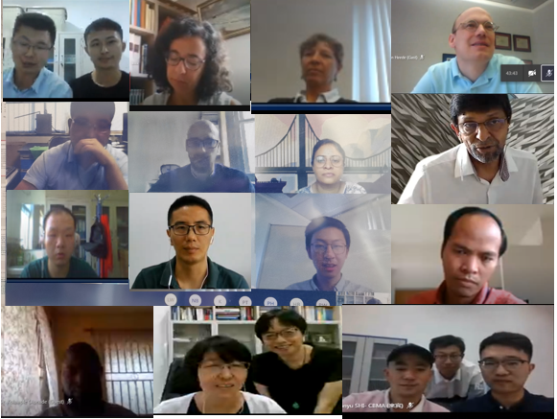
The group photo for the 3rd meeting of RILEM TC CCC WG4

